Setup Development Environment

1. Select Your Operating System (OS): Choose an operating system that best suits your preferences and project requirements. Download and Install Windows 11. https://www.microsoft.com/software-download/windows11

STEPS;

* Check System Requirements:

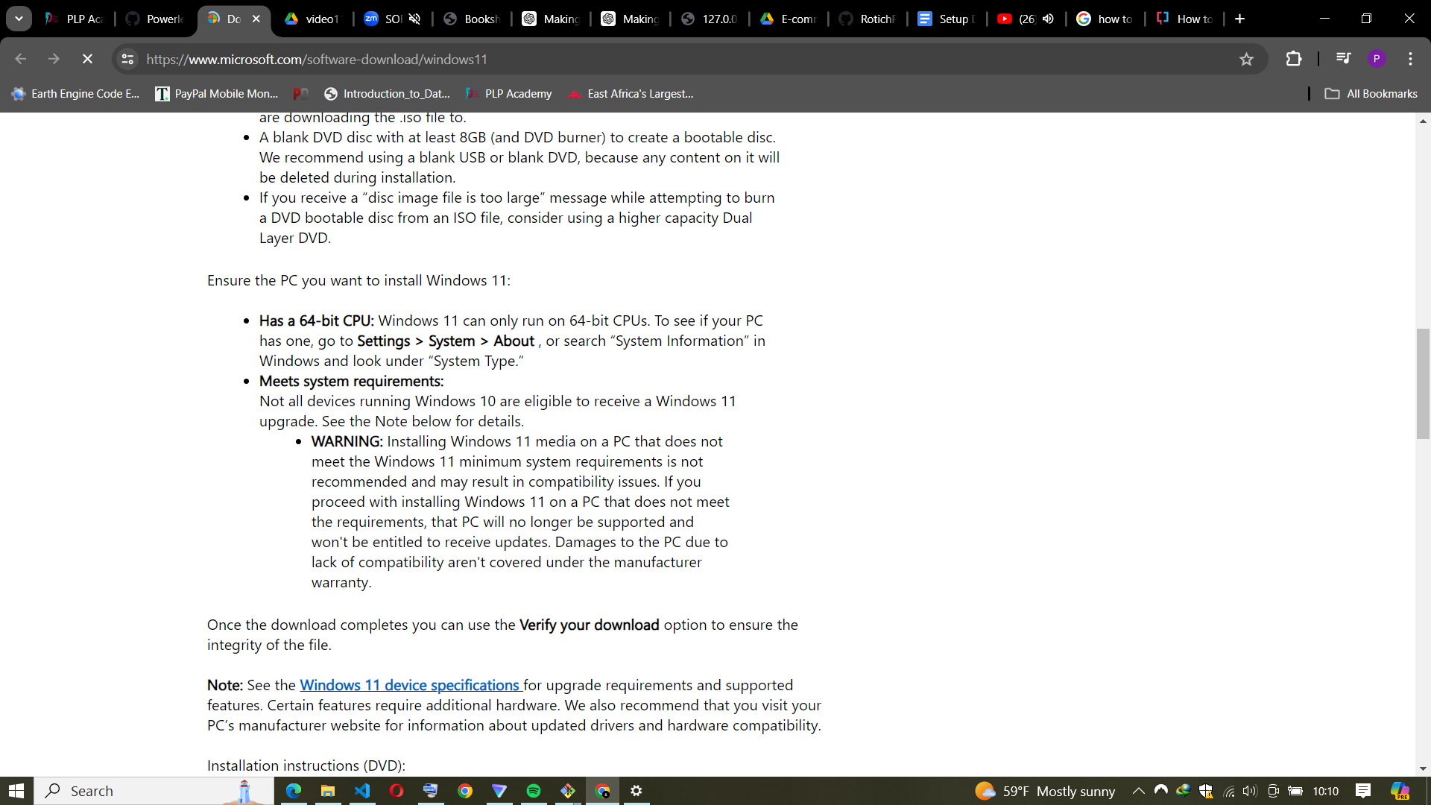

* Verify that your PC meets the minimum requirements for Windows 11. These include a compatible 64-bit processor, 4 GB of RAM, and 64 GB of storage. Your device must also support Secure Boot and TPM 2.0.

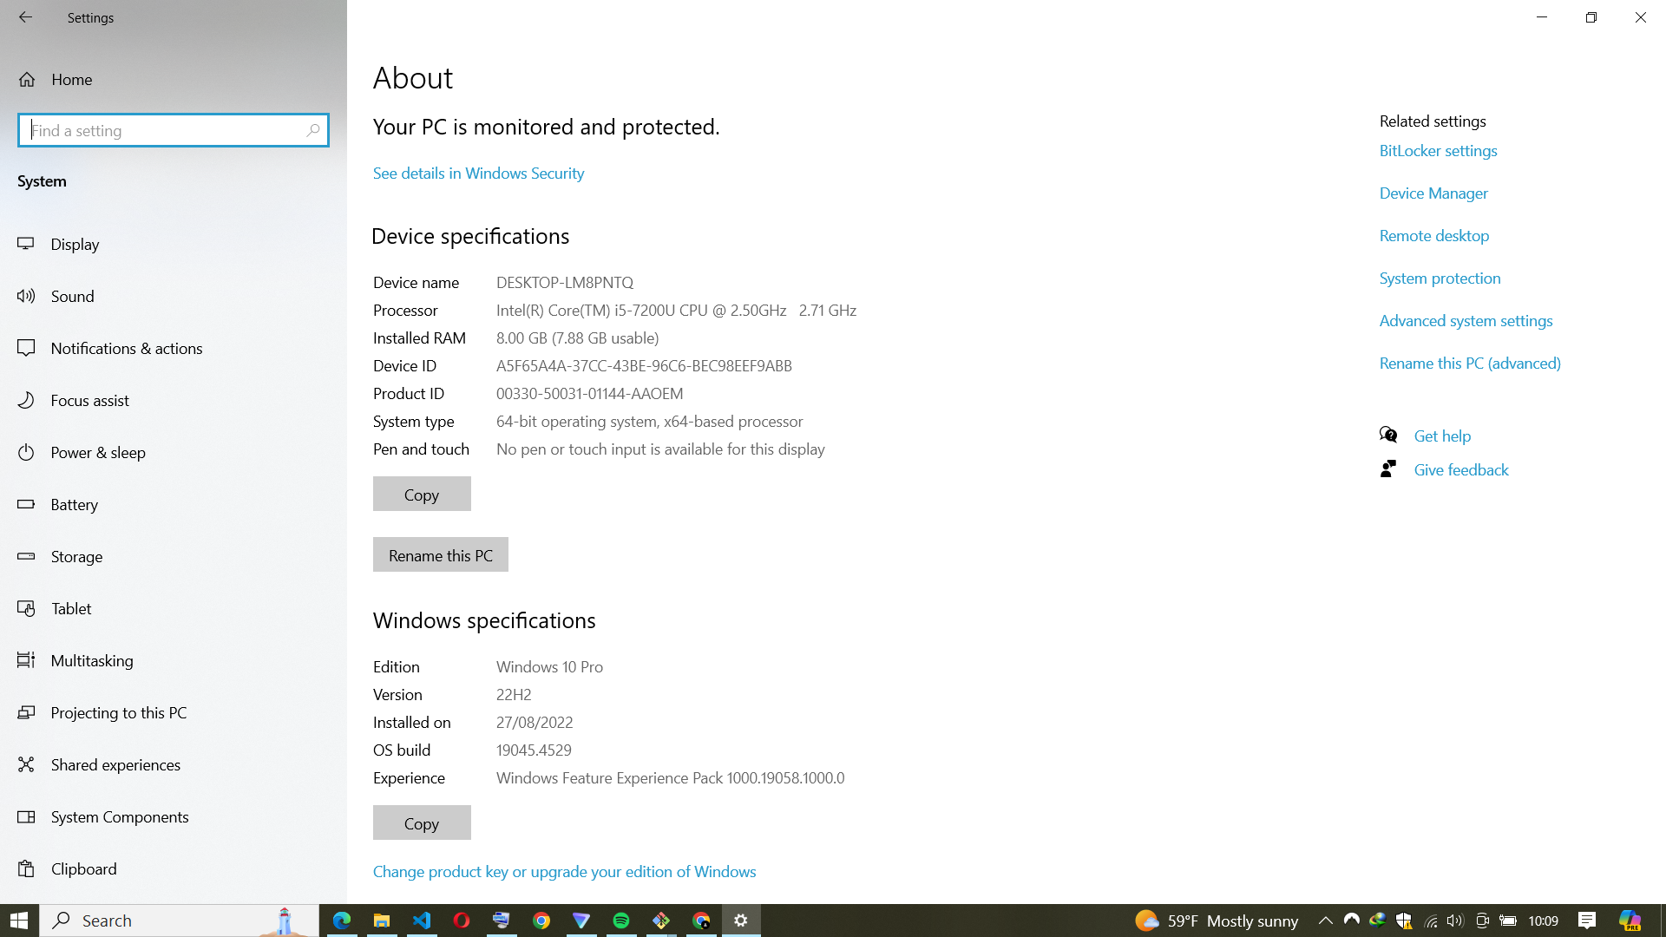

* Backup Your Data:
* Before proceeding, backup your important files and data. Upgrading may involve data migration, so it’s essential to have a backup.
* Download Windows 11 Installation Assistant:

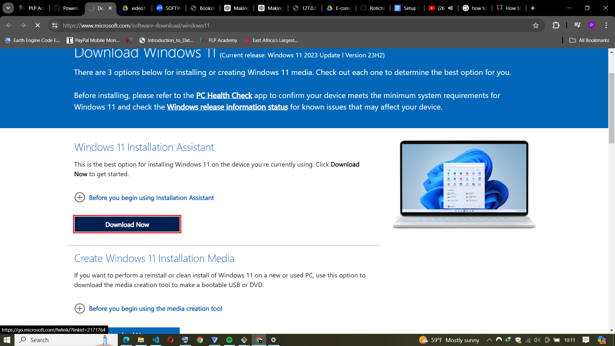

* Visit the official Microsoft website and download the Windows 11 Installation Assistant.
* Run the installer and follow the on-screen instructions.
* Upgrade Process:
* The installation assistant will check your system compatibility.

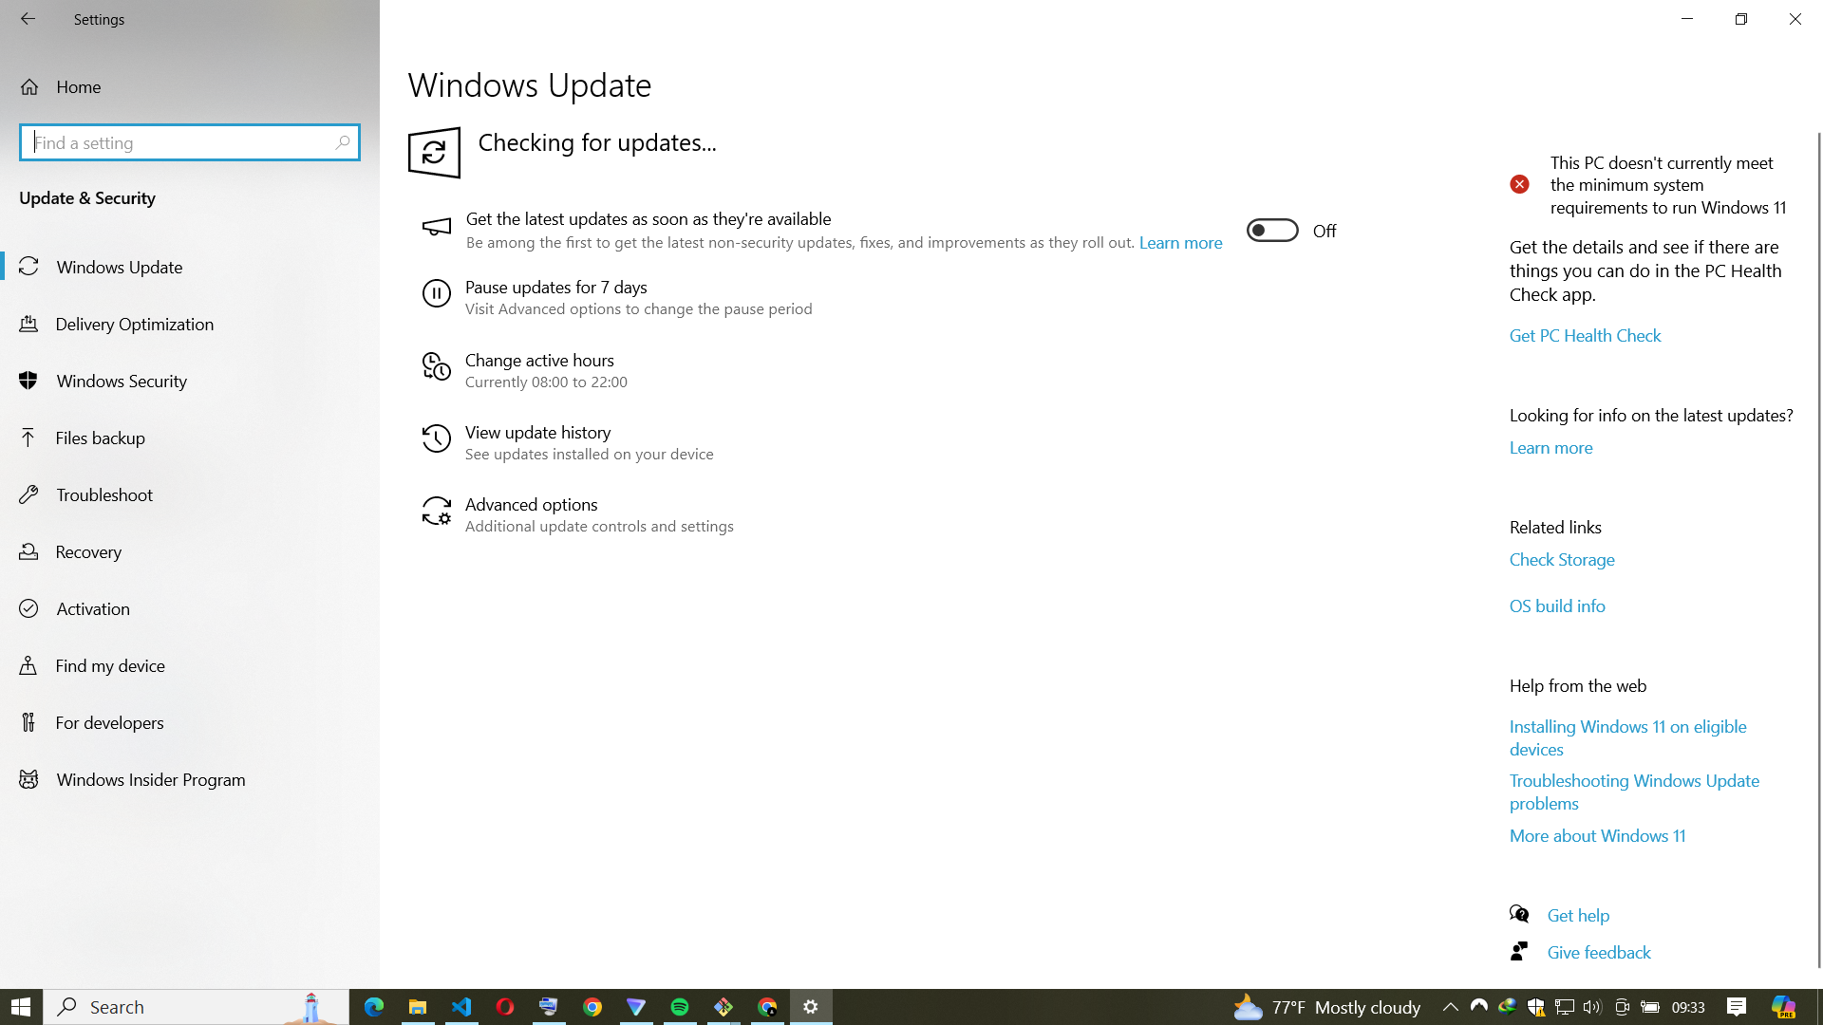

* If your PC meets the requirements, it will proceed with the upgrade.
* Follow the prompts to complete the installation.
* Post-Upgrade Steps:
* After installation, set up your preferences, sign in with your Microsoft account, and customize settings.
* Check for Windows updates to ensure your system is up to date.

1. Install a Text Editor or Integrated Development Environment (IDE): Select and install a text editor or IDE suitable for your programming languages and workflow. Download and Install Visual Studio Code. <https://code.visualstudio.com/Download>

Steps:

* Download VS Code:
* Visit the official VS Code website.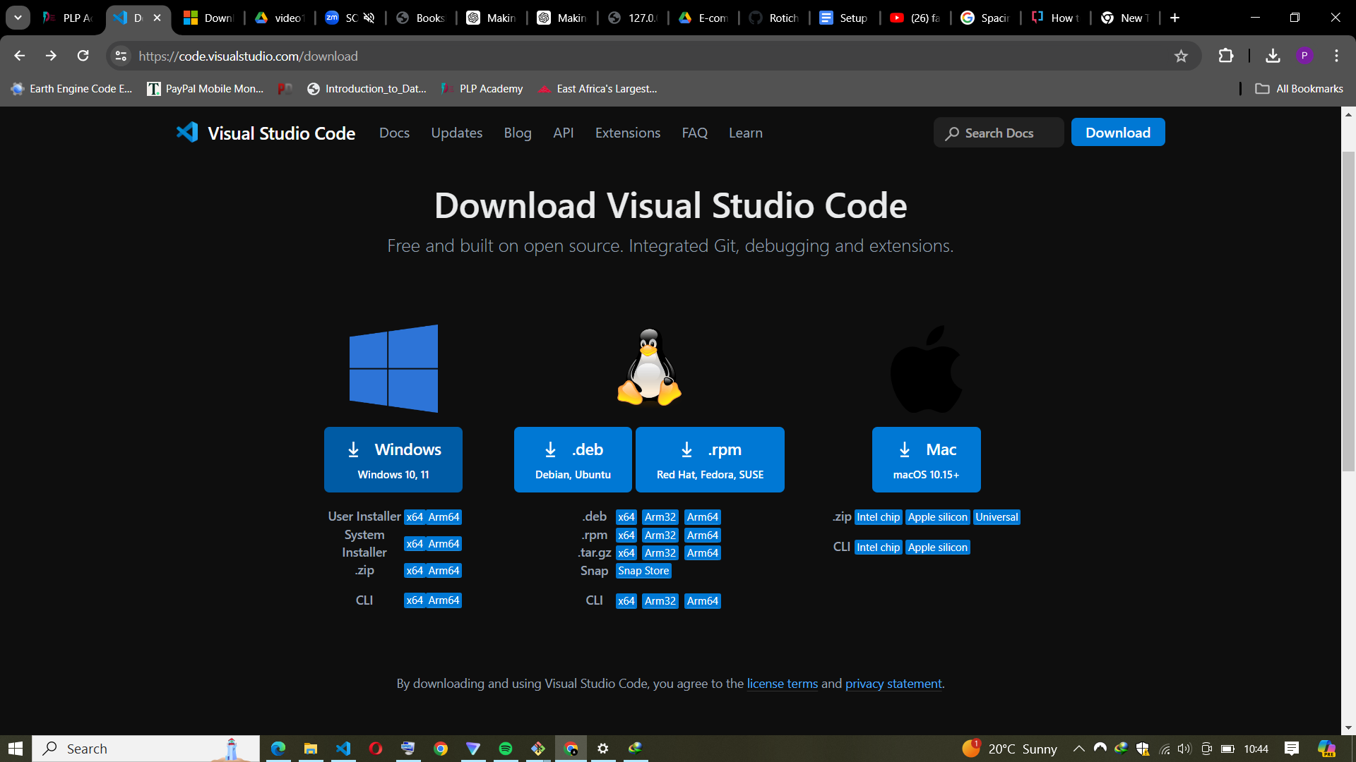
* Click the Windows button to download the installer.
* Save the file on your device.

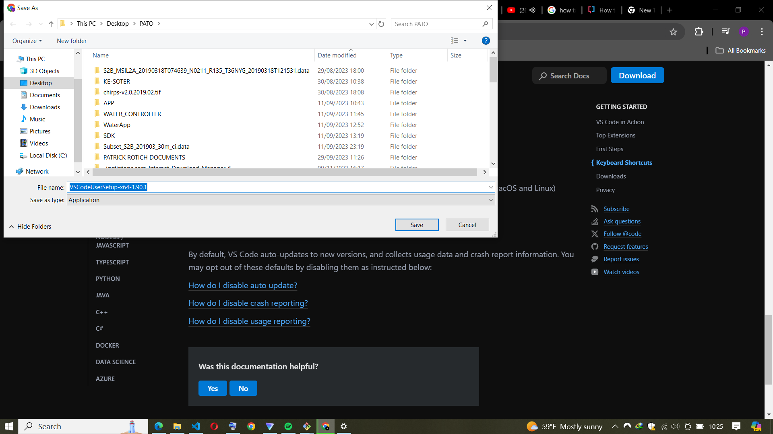

* Install VS Code:
* Double-click the downloaded file (usually named VSCodeUserSetup-{version}.exe).
* Follow the installation prompts. Accept the terms and conditions.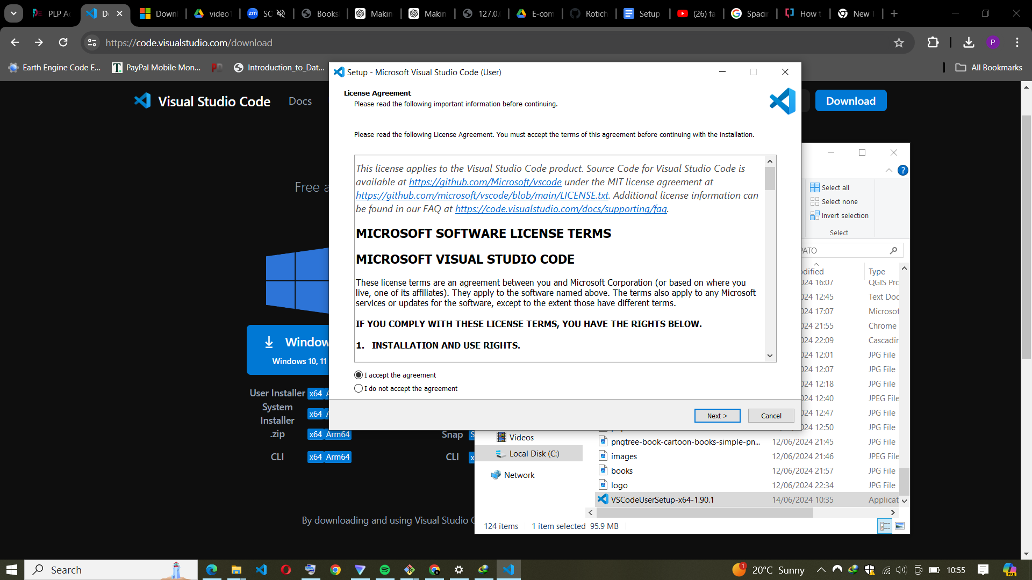
* By default, VS Code will be installed under C:\Users\YourUsername\AppData\Local\Programs\Microsoft VS Code.
* Launch VS Code:
* After installation, click the Launch button to start VS Code.

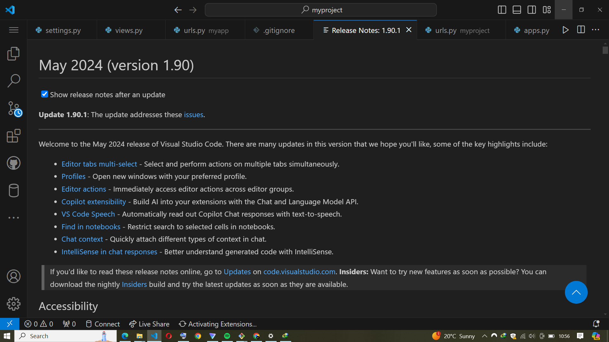

1. Set Up Version Control System: Install Git and configure it on your local machine. Create a GitHub account for hosting your repositories. Initialize a Git repository for your project and make your first commit. <https://github.com>

STEPS

* Install Git on Windows
* Navigate to the latest Git for Windows installer and download the latest version.

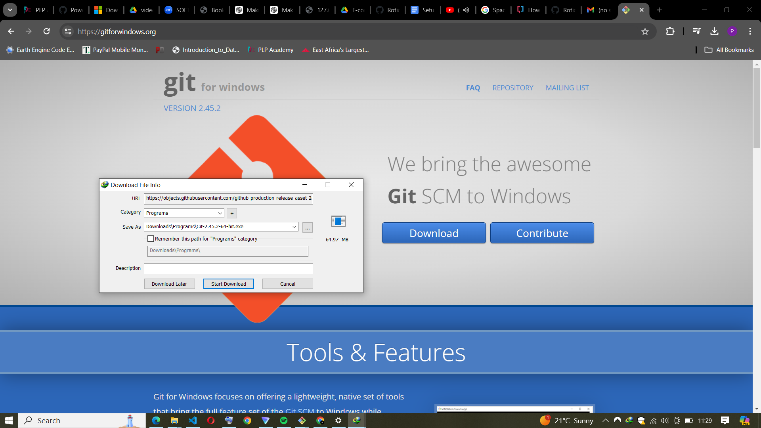

* Once the installer has started, follow the instructions as provided in the Git Setup wizard screen until the installation is complete.

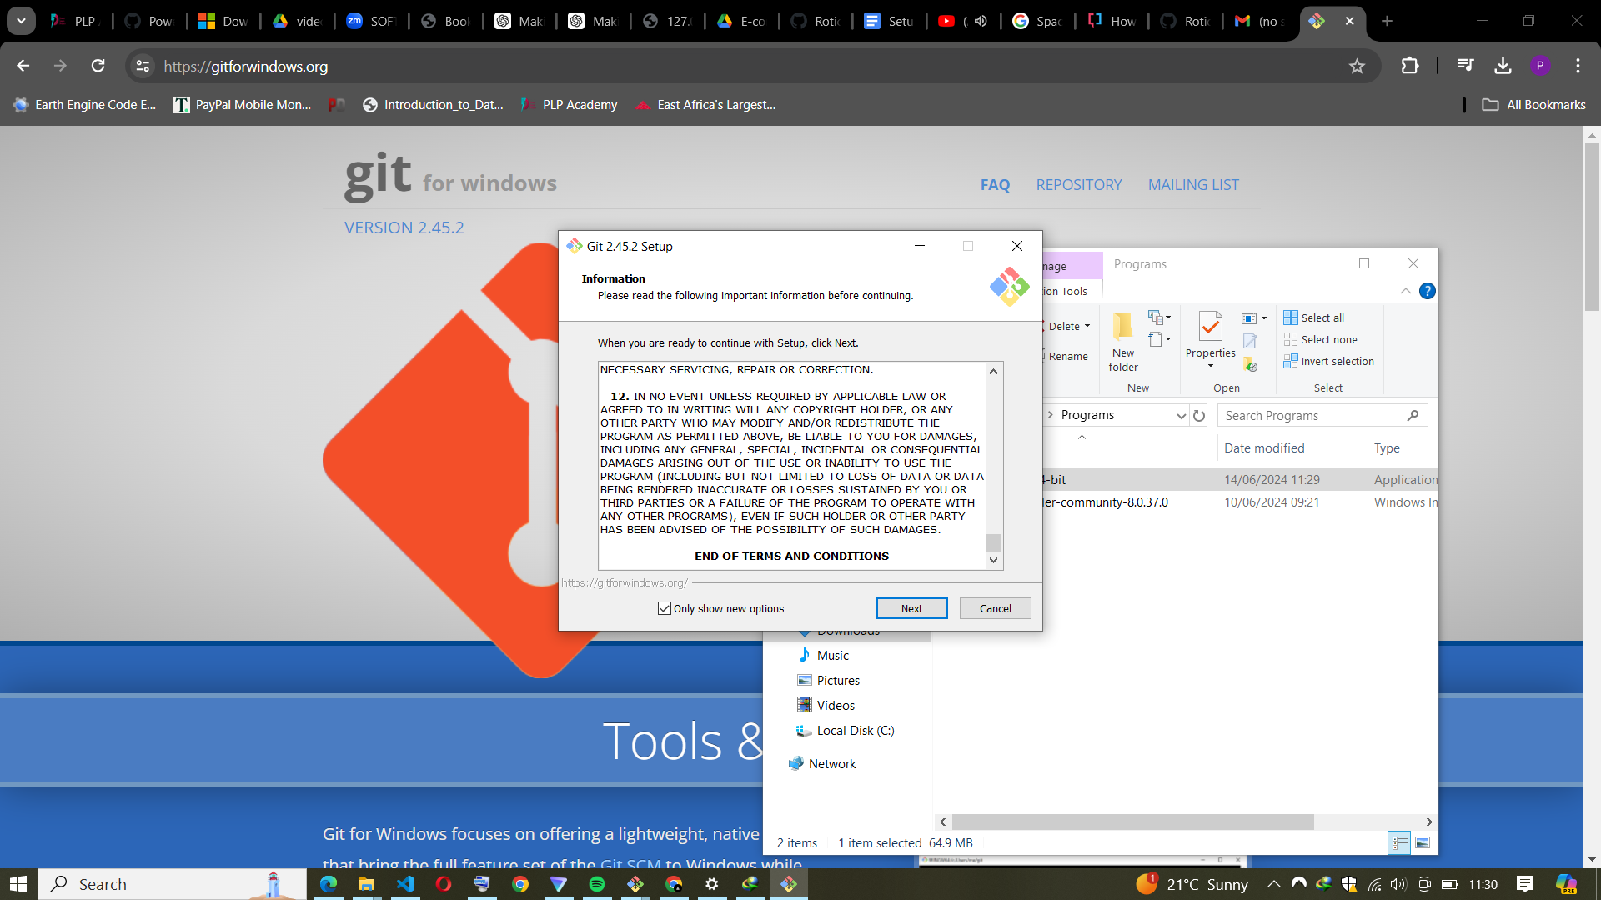

* Open the windows command prompt (or Git Bash if you selected not to use the standard Git Windows Command Prompt during the Git installation).
* Type git version to verify Git was installed.

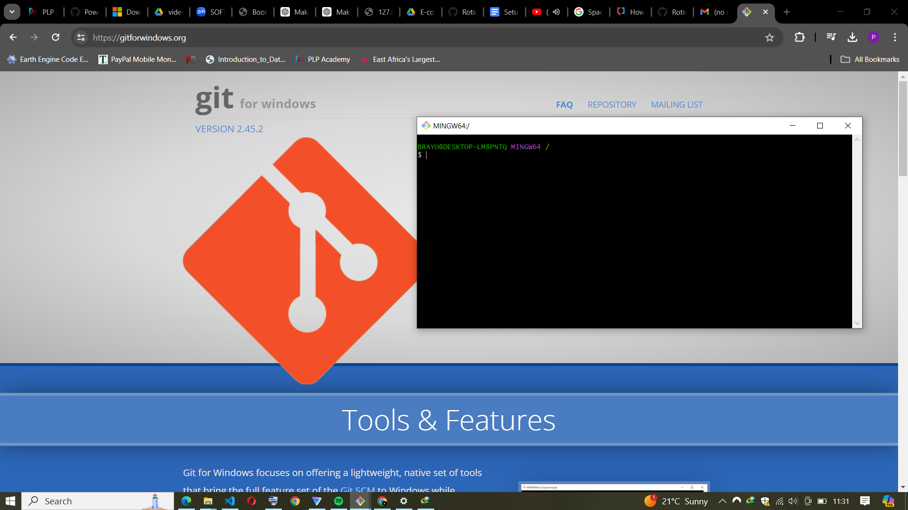

* Note: git-scm is a popular and recommended resource for downloading Git for Windows. The advantage of downloading Git from git-scm is that your download automatically starts with the latest version of Git included with the recommended command prompt, Git Bash . The download source is the same Git for Windows installer as referenced in the steps above.

**GitHub**

* If you don’t have an account, sign up on the GitHub website.



* Sign in to GitHub:
* Once logged in, click on “Repositories” to access the repositories page.
* Create a New Repository:
* Click the “New repository” button (usually at the top left corner)

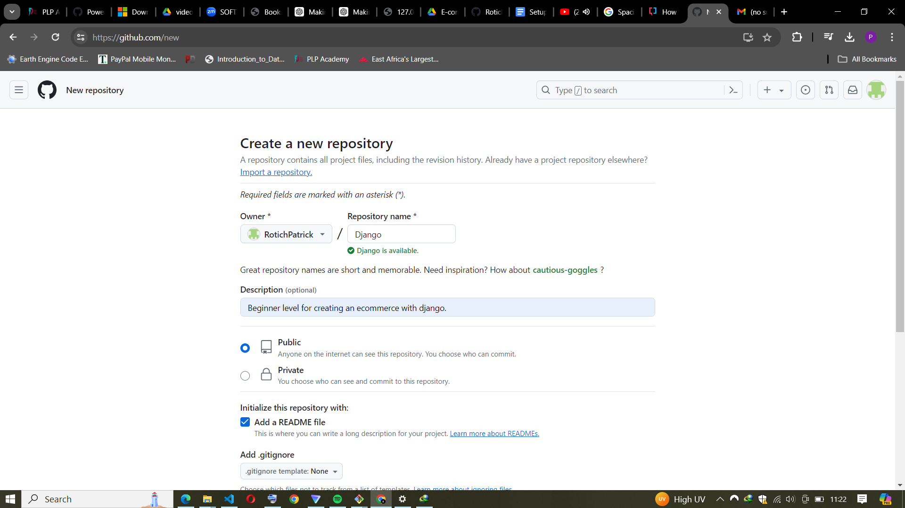.

* Provide a name for your repository and an optional description.
* Choose visibility (public or private).
* Optional Pre-Populated Items:
* You can add a README (a document describing your project).
* Create a .gitignore file (set of ignore rules).
* Click “Create repository.”

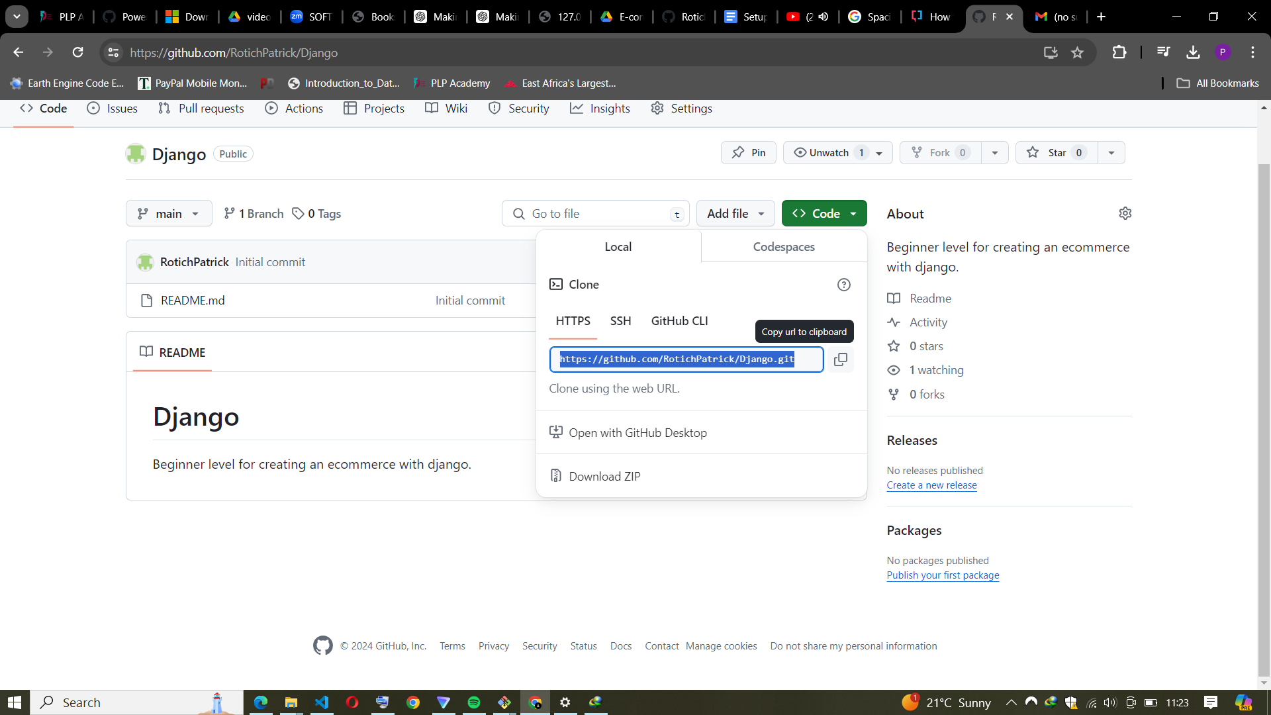

* Copy the Repo URL:
* From the browser address bar, copy the Git repository URL.

1. Install Necessary Programming Languages and Runtimes: Install Python from http://wwww.python.org programming language required for your project and install their respective compilers, interpreters, or runtimes. Ensure you have the necessary tools to build and execute your code.

STEPS

* First, go to the Python website and click on the “Download Python” button. Select the latest version.

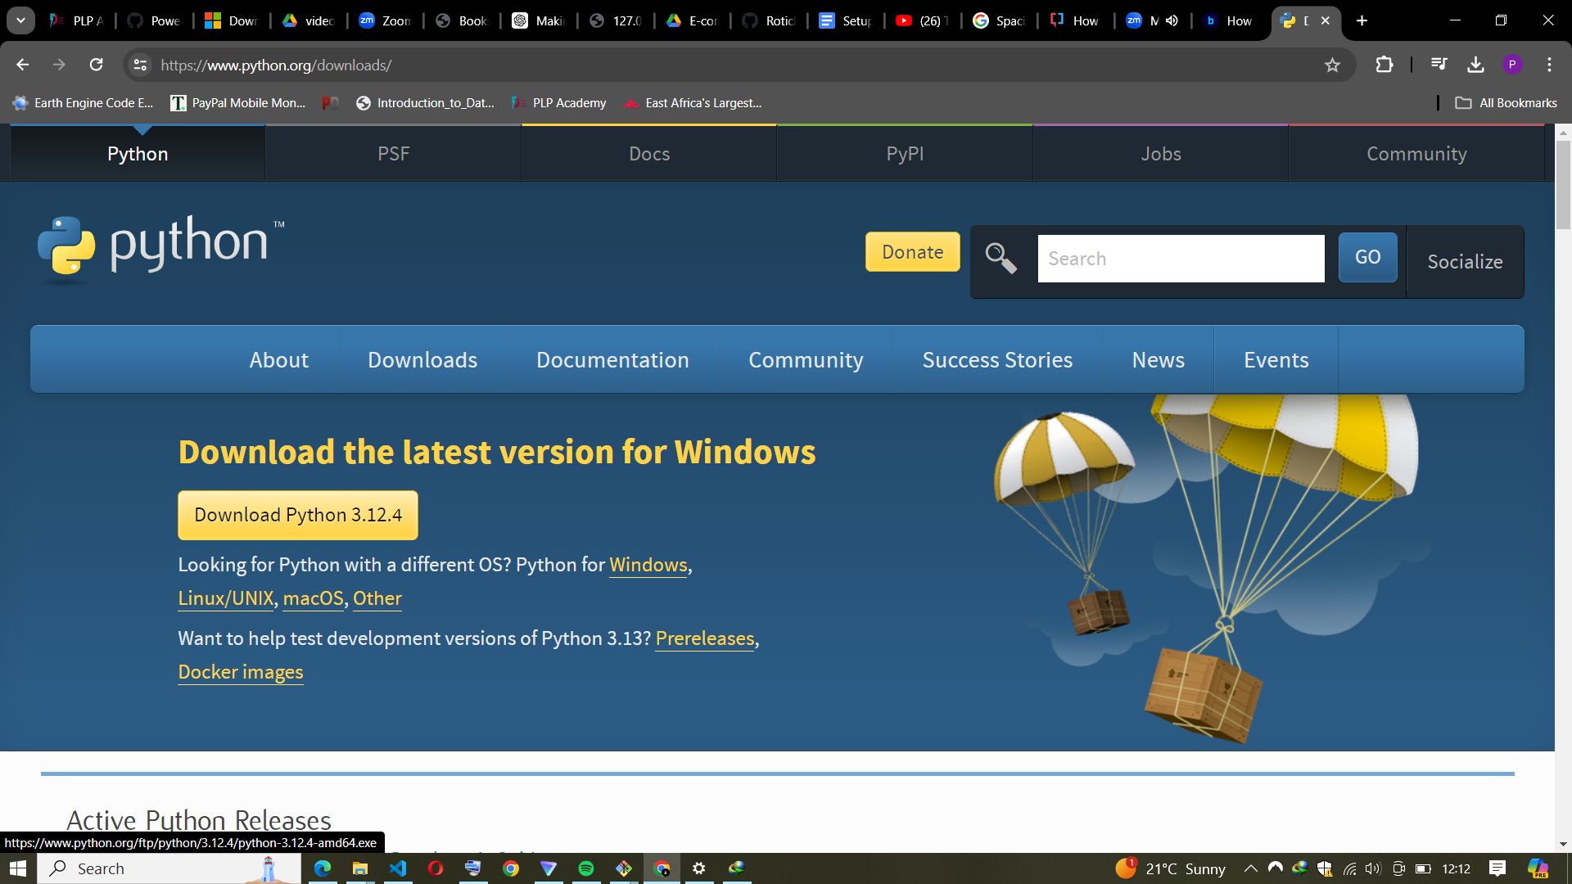

* Select the “Windows installer” option and click on the “Download” button. Once the download is complete, run the installer.

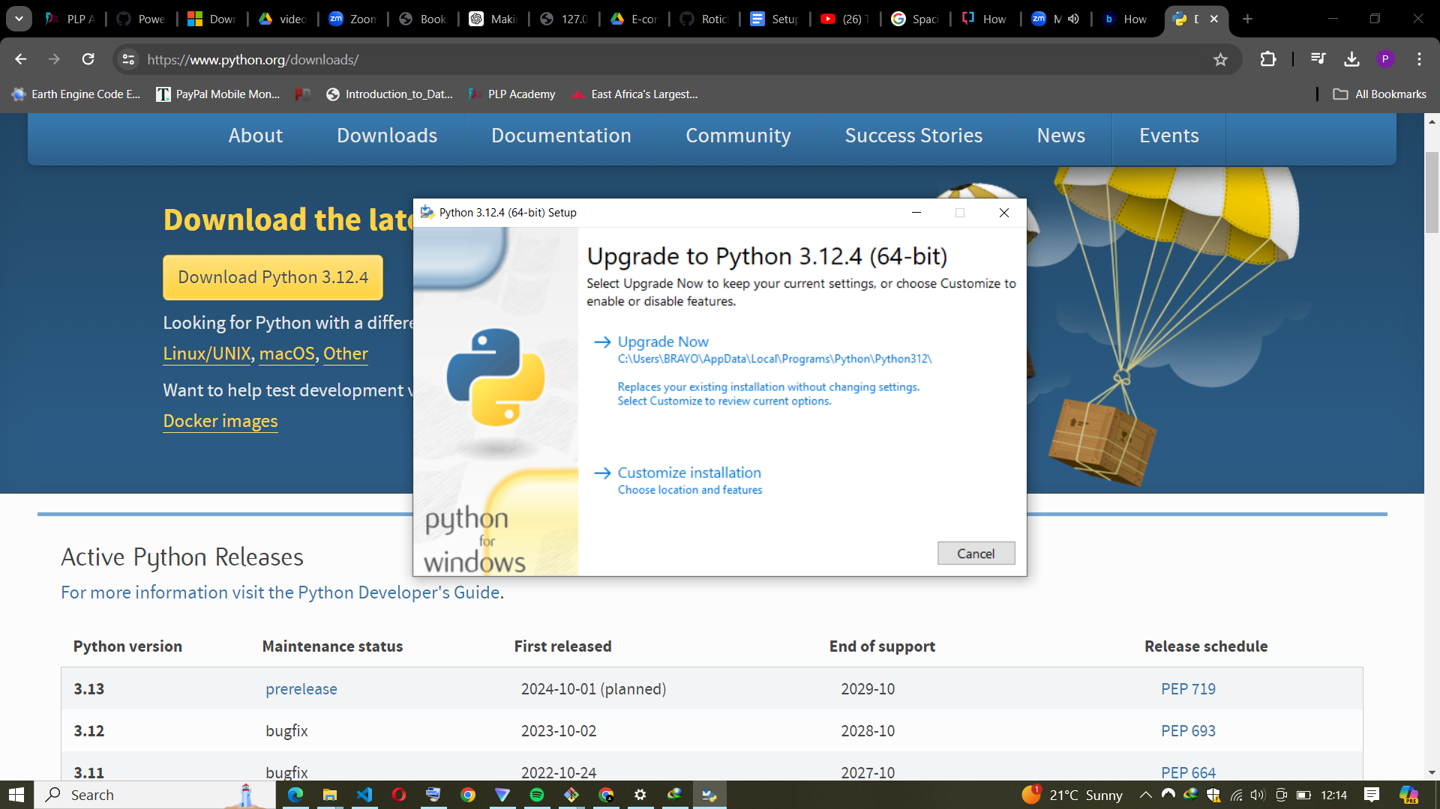

* During the process, it’s advisable to check the boxes “Use admin privileges when installing py.exe” and “Add python.exe to PATH” to save the trouble of manual adjustments in the environment variable later.
* Then, follow the on-screen instructions to install Python. Once the installation is complete, you should see a success message like this:
* Successful Python installation for Windows.
* You can verify that Python has been installed by opening a command prompt and typing the following command: python -V.

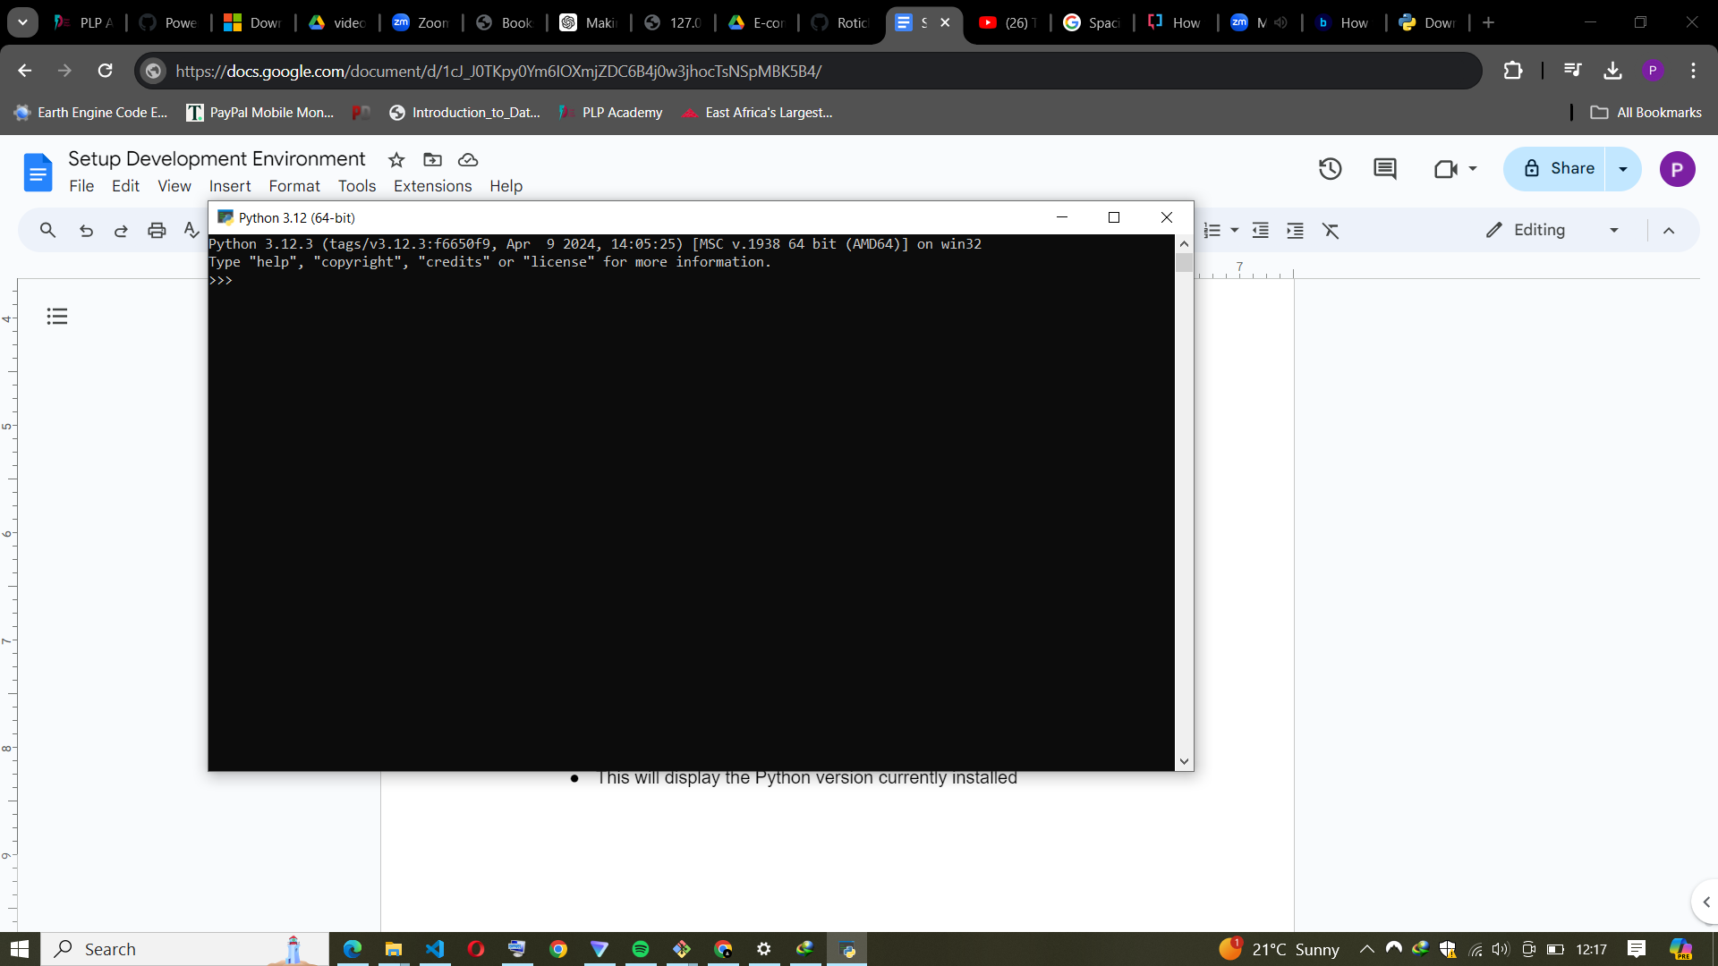

* This will display the Python version currently installed

1. Install Package Managers: If applicable, install package managers like pip (Python).

STEPS.

* Verify Python and pip Installation:
* Open a terminal or command prompt.
* Check the Python version by running:

python --version

* Check the pip version by running:

pip --version

* Upgrade pip.

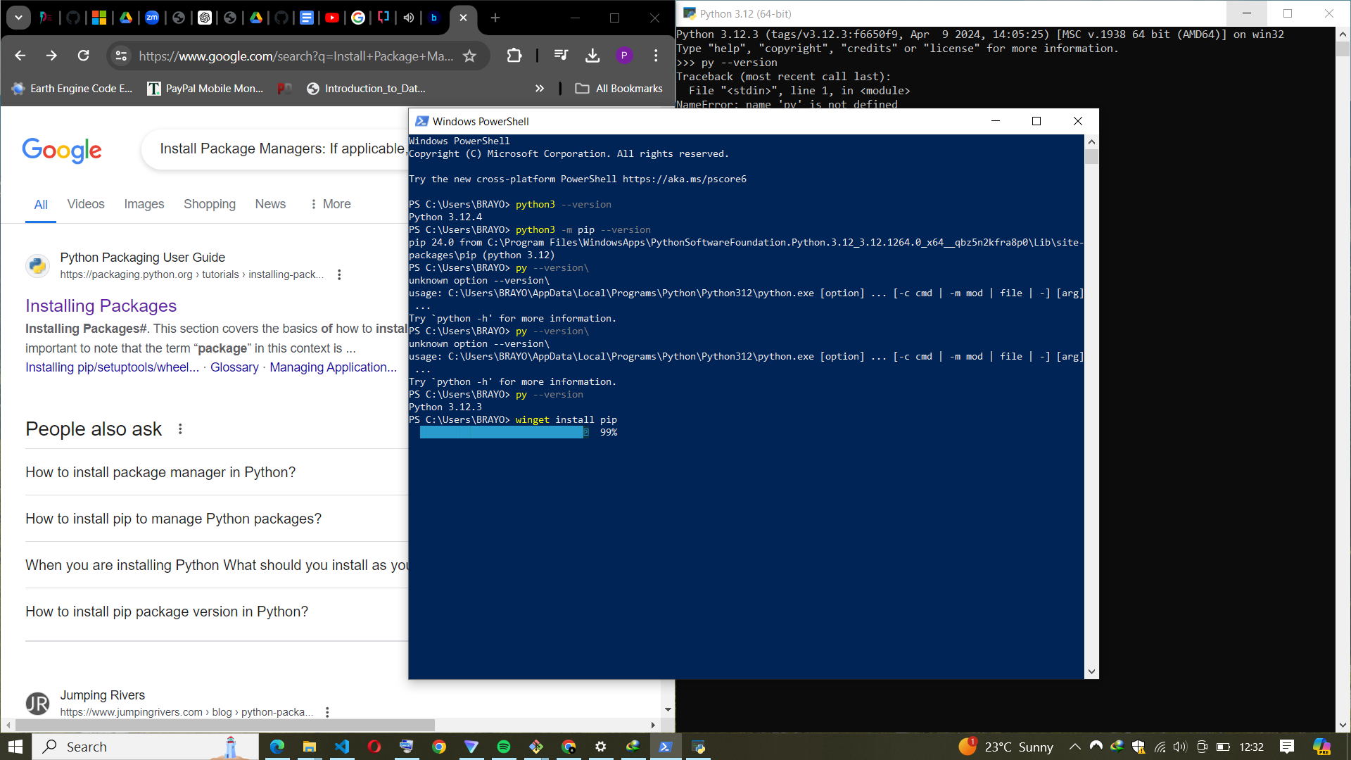

* Run the following command to ensure you have the latest version of pip:

python -m pip install --upgrade pip

1. Configure a Database (MySQL): Download and install MySQL database. <https://dev.mysql.com/downloads/windows/installer/5.7.html>

STEPS.

In windows:

* Visit the official MySQL website.
* Select the MySQL installer appropriate for your operating system

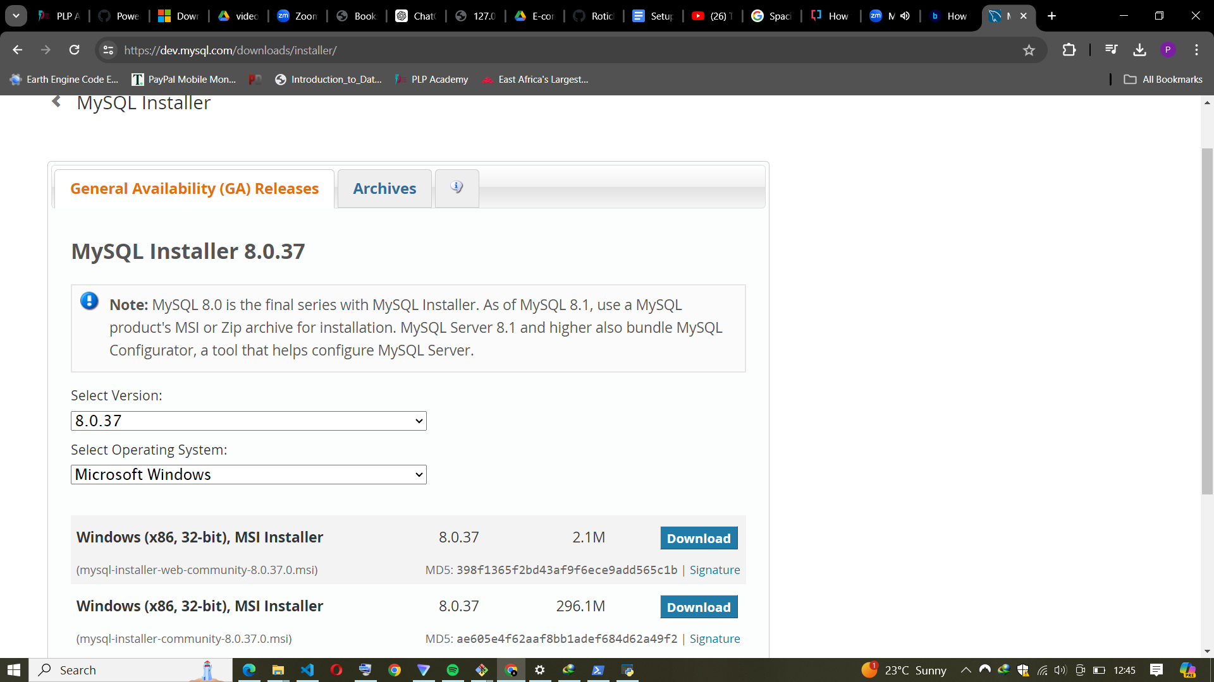

* For Windows, download the "MySQL Installer" (choose the web community version for a smaller download).
* Run the downloaded MySQL Installer.
* Select "Custom" or "Developer Default" depending on your needs.
* Follow the prompts to choose the components you want to install (e.g., MySQL Server, MySQL Workbench).

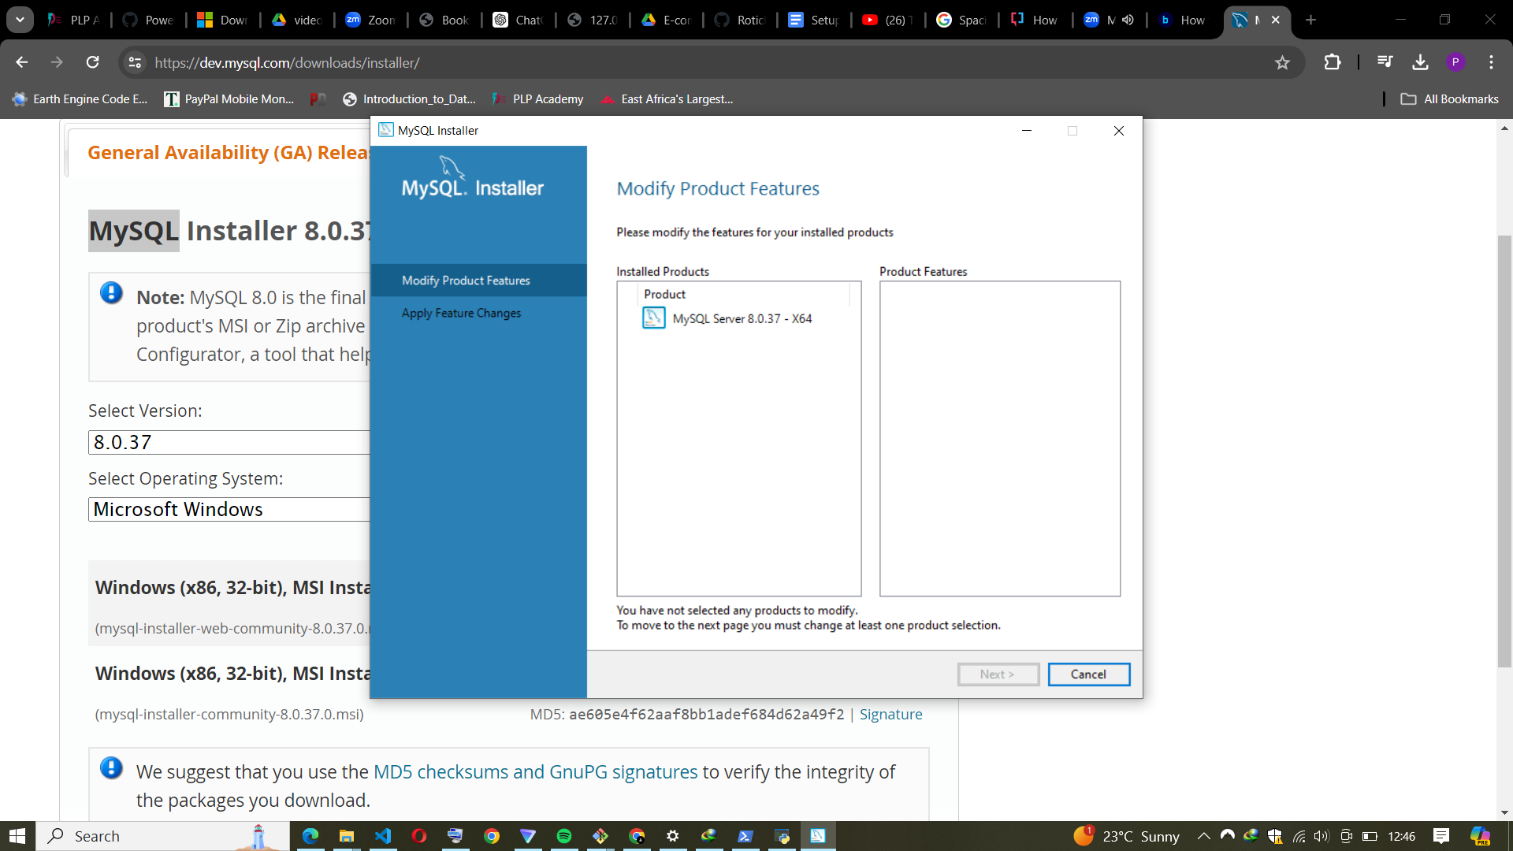

* Configure MySQL Server by setting a root password and selecting a port (default is 3306).

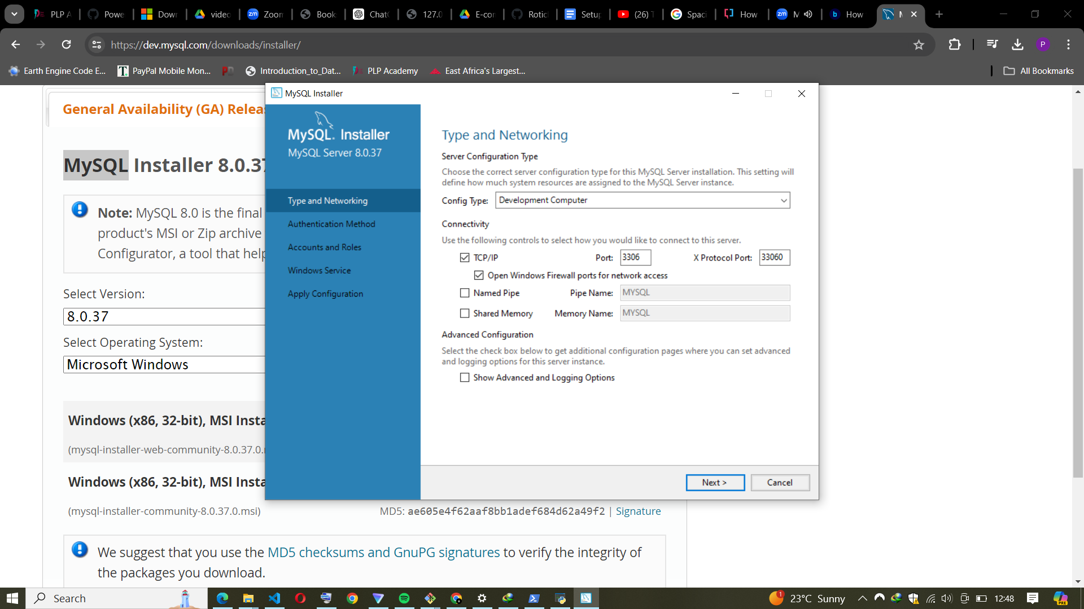

* Complete the installation.
* Verify MySQL Installation:
* Open a terminal or command prompt.
* Connect to the MySQL server:
* Enter the root password you set during installation.

2. Explore Extensions and Plugins: Explore available extensions, plugins, and add-ons for your chosen text editor or IDE to enhance functionality, such as syntax highlighting, linting, code formatting, and version control integration.

